Windows Application Development using ASP.Net MVC

**Project 1: Small Business Management System**

**Name of Project:** Small Business Management System

**Type of application:** Windows Application

**Technology Stack:** C#, MVC, MS SQL Server

Team will be scored using following scoring benchmark.

|  |  |  |
| --- | --- | --- |
| **SL#** | **Story Name** | **Score** |
| **1** | Product Catalog Module (Category) | 2 |
| **2** | Product Catalog Module (Product) | 2 |
| **3** | Party Module (Customer) | 2 |
| **4** | Party Module (Supplier) | 2 |
| **5** | Purchase Module | 3.5 |
| 6 | Sales Module | 3.5 |
| 7 | Stock Module (Search/View) | 3 |
| **8** | Stock Module (Stock Out) | 3 |
| **9** | Stock Module (Stock Re-Order) | 3 |
| **10** | Reporting Module (Periodic Income Expense Report on Sales) | 3 |
| **11** | Reporting Module (Periodic Income Expense Report on Purchase) | 3 |
|  | **Total** | **30** |

Each member score (50) = Team Score (30) + Individual Score (20)

Individual score will be counted as your contribution.

Every team member must contribute equally. During project presentation, everyone will be asked about his/her contribution and score accordingly. During presentation, you will run your application and will show what you have completed so far. We will ask you about the source code and code quality, database design and data quality, member’s contribution (github & trello). Your git repository, trello and release phases are the verification of your work. Note that before final presentation every one must complete all release phases (contains marks) works.

***Please note that if any members don’t write any code or fails to complete release phases will get score zero and it will also affect your group score*.**

**Description of Project:**

ABC Company is a small retail company, they purchase their products and sale the products with a profit margin. Currently they are managing their business manually, for that reason ABC Company is suffering to manage their stocks and sale management information, also the purchase information’s on their products as they needed more time to summarize the result.

So, ABC wants an automation system which will manage their small business, and they will be able to manage their products, purchases, stocks and sales, with which they could have right data on time and with less effort.

**What ABC Company Needs?**

1. To Manage their Purchases
2. To Manage their Stock
3. To Manage Their Sales
4. To Track Loss or Profit

**So we could divide the solution into various Modules**

1. Product Catalog Module.
2. Purchase Module
3. Stock Module
4. Sales Module
5. Party Module (Customer/Supplier)
6. Reporting Module

Module Details:

1. Product Catalog
2. Product Category Setup (View, Entry, Edit, Search)
3. Product Setup with Category (View, Entry, Edit, Search)

2. Party Module

1. Customer Setup (View, Entry, Edit, Search)
2. Supplier Setup (View, Entry, Edit, Search))

3. Purchase Module

1. Purchase Entry
2. Purchase Edit
3. Purchase View and Search

4. Sales Module

1. Sales Entry
2. Sales Edit
3. Sales View and Search

5. Stock Module

1. Periodical Stock Report (From – To Date, Opening Balance, In, Out, Closing Balance of Product Quantity)
2. Find Re-Order Product & Expired Product.
3. Stock-Out Damaged and Lost Product

6. Reporting Module

1. Periodic Income Expense / Profit Report on Sales
2. Periodic Projected Income Expense / Profit Report on Purchase

**STORY**

1. **Product Catalog Setup**

1. **Product Category Setup**

As a Admin

I want to Manage (Save, Modify and View/Search) Categories (Name, Code)

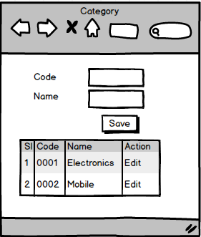So that I can manage Products as per their Category

Acceptance Criteria:

Initially show available records

Data can be added or modified any time

Each data (Name, Code) must be uniquely identified (unique)

Must provide all data (Name, Code)

Code must be 4 characters in length

User can search by Name, Code

1. **Product Setup with Category**

As a Admin

I want to Manage (Save, Modify and View/Search) Products (Name, Code, Reorder Level, Category and Description)

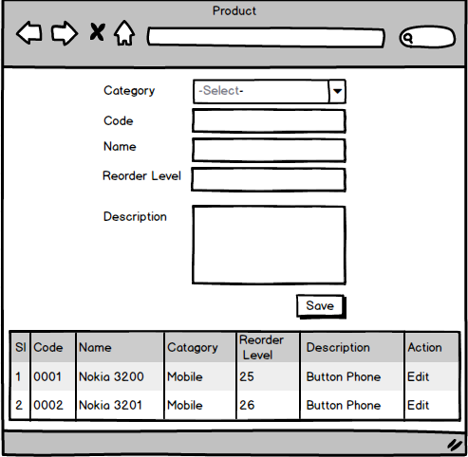So that Purchase and Sales Team can use the Products

Acceptance Criteria:

Initially show available records

Data can be added or modified any time

Each data (Name, Code) must be uniquely identified (unique)

Must provide all data (Category, Name, Code, Reorder Level)

Code must be 4 characters in length

Initially Reorder Level should be 10 or as per user (but only positive number allowed)

User can search by Category, Name and Code

2. **Party Module**

a. **Customer Entry, Edit, Search**

As a Admin

I want to Manage (Save, Modify and View/Search) Customers (Name, Code, Address, Contact, Email, and Loyalty Point)

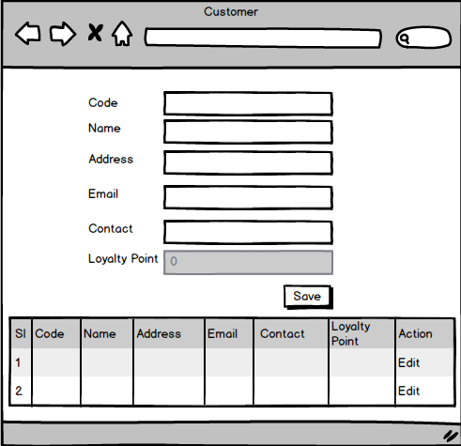So that I can gain profit Customers

Acceptance Criteria:

Initially show available records

Data can be added or modified any time

Code, Contact, Email must be uniquely identified (unique)

Must provide Code, Name, Contact and Email

Code must be 4 characters in length

Initially Loyalty Point should be 0 or as per user provides

User can search by Name, Contact and Email

1. **Supplier Entry, Edit, Search**

As a Admin

I want to Manage (Save, Modify and View/Search) Supplier (Name, Code, Address, Contact Person and Email)

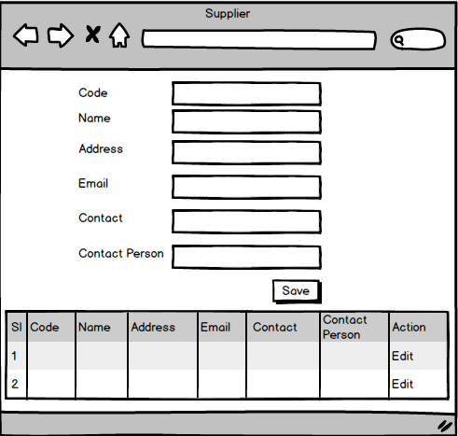So that I can save Supplier

Acceptance Criteria:

Initially show available records

Data can be added or modified any time

Code, Contact, Email must be uniquely identified (unique)

Must provide Code, Name, Contact and Email

Code must be 4 characters in length

User can search by Name, Contact and Email

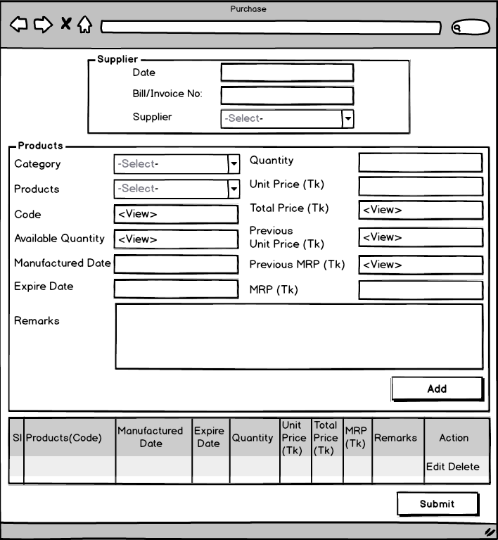3. **Purchase Module**

As an Admin / Purchase Manager

I want to Manage (Save, Modify And View/Search) purchase (Code, Date, Bill/Invoice number, Supplier, Category, Product, Code, Available Quantity, Manufactured Date, Expire Date, Purchased Quantity, Unit price, Remarks)

So that Business Owner, Purchase team can have up-to-date purchase information

Acceptance Criteria:

Initially show available records

Purchase code will be automatically generated as 2019-0001

Product is selected as per Category

Data can be added or modified any before submit

Bill/Invoice number must be uniquely identified (unique)

User can search by Code, Date and View details

**[MRP Calculation Formula: MRP = Unit Cost + 25% of Unit Cost]**

On purchase (Submit) stock quantity will be increased

**4. Sales Module**

As a Sales man

I want to Manage (Save, Modify and View/Search) Sales (Code, Customer, Date, Product, Quantity and Price)

So that Business Owner, Purchase team can have final up-to-date sales information and give discount/offer on loyalty point.

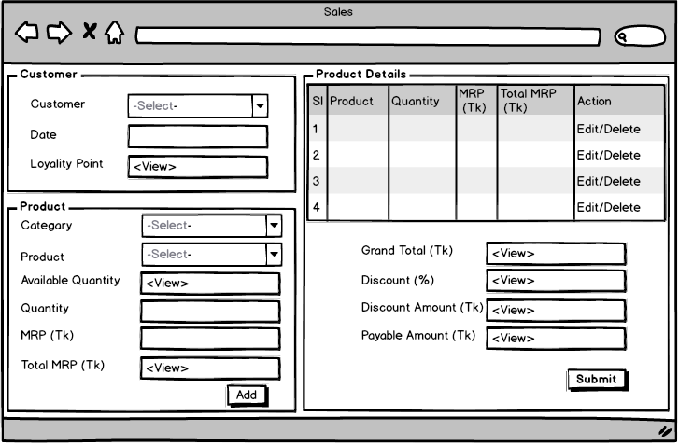

Acceptance Criteria:

Data can be added or modified until it is submitted

Sales code will be automatically generated as 2019-0001

User can search by Sales Code, Date and Customer

Stock quantity will be decreased on sales

On purchase price customer will gets loyalty point

**[Loyalty Point Calculation Formula: Loyalty Point will be increased by [Grand Total/1000] Point(s)]**

On loyalty point customer will gets discount

**[Discount (%) Calculation Formula: Loyalty Point/10 and Reset Loyalty Point]**

**[Reset Loyalty Point: Loyalty Point - Loyalty Point/10]**

Product should be sold by following FIFO (First in First out) method.

User will be notified if quantity goes below the Reorder level

**5. Stock Module**

1. Periodical Stock Report (From - To, Opening Balance, In, Out, Closing Balance)

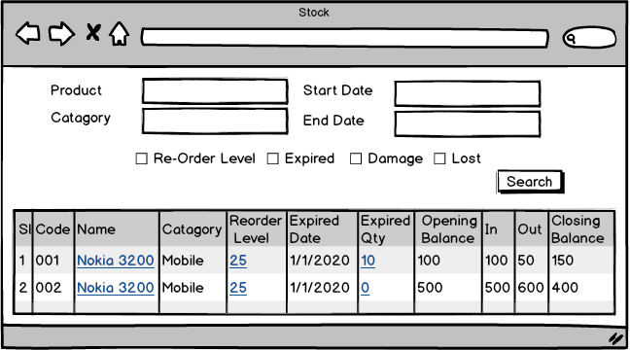

As a Inventory Manager

I want to track Available Products/ Re-Order Products/ Expired Products and Stock out Lost or Damaged Products

So that I can get clear idea about stock.

Acceptance Criteria:

By default Low Reorder Level product & closely expired product will be shown on top

1. 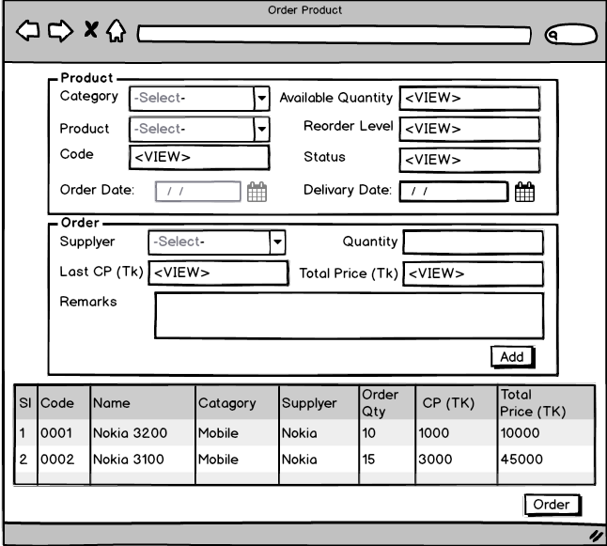Order Prduct

As a Inventory Manager

I want to reorder the products

So that products never runs out and loss can be minimized

Acceptance Criteria:

Already ordered cannot be reordered

Order can be searched

When order is purchased its status should be changed.

1. 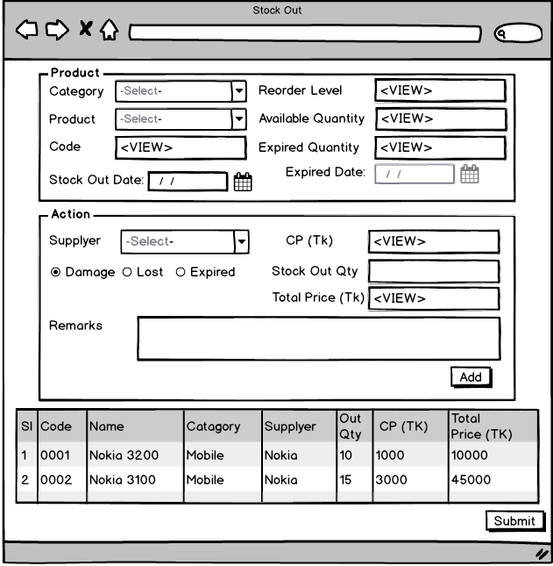Stock Out Expired, Damage or Lost Product

As a Inventory Manager

I want to reorder the products

So that products never runs out and loss can be minimized.

Acceptance Criteria:

Order can be searched

**6. Reporting Module**

1. 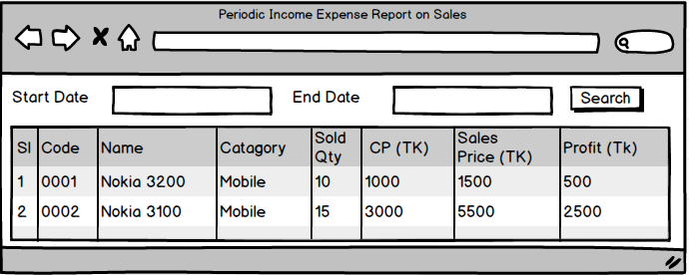Periodic Income Expense Report on Sales

As an Owner

I want to find out my periodic profit on sales

So that I can track my business growth

1. 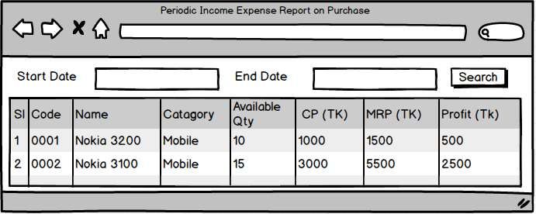Periodic Income Expense Report on Purchase

As an Owner

I want to find out my expected profit on purchased items (Available Item)

So that I can track my future business growth